Fischer-Tropsch

There are several Fischer-Tropsch reactors in operation: multi-tubular fixed bed (trickle flow), fluidized bed / risers and slurry columns. For this workshop we will consider the low temperature (< 260 oC) slurry reactor. We will approach the problem in the simplest way possible while still capturing the essentials.

For simplicity we will only consider the main reaction:

Reaction 1: CO + 2H2 🡪 CH2 + H2O

The reaction rate is given by:

$$-R_{CO}=K_{r}C_{CO}^{l}=1.5×{10}^{-4}C_{CO}^{l} \frac{mol CO}{{kg}_{cat}s}$$

$C_{CO}^{l}$ is the CO concentration in the liquid phase. Kr is determined at 515 K.

For the modelling we use the model proposed by Krishna, which includes the liquid phase, small bubbles and large bubbles. The large bubbles move in plug flow, while the liquid and the small bubbles are close to a CSTR. The latter we will model using the axial dispersion model.

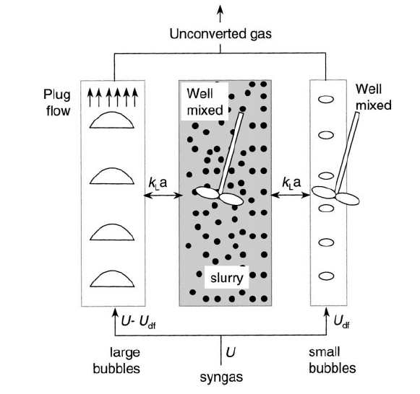

The dense phase consists of the liquid phase plus the catalyst plus the small bubbles.

The following correlations can be used:

Rise (linear) velocity of the small bubbles:

$$V_{SB}=0.095×(1+\frac{0.8ϵ_{p}}{0.095})$$

In which $ϵ_{p}$ is the hold-up of catalyst in the dense phase in m3 catalyst / m3dense phase. The dense phase is the liquid plus catalyst plus the small bubbles.

The hold-up of small bubbles is given by (m3 small bubble / m3 volume dense phase):

$$ϵ_{SB}=0.6072×(1-\frac{0.7ε_{p}}{0.27})$$

We can now calculate the superficial velocity of the small bubbles (USB):

By means of the over balance we now also know the superficial velocity of the large bubbles (ULB):

In this equation Ug is the overall superficial velocity (m3 gas/ s divided by the total flow area of the column). We will use Ug as a design variable which we can vary.

The hold-up of large bubbles is given by (m3 large bubble / m3 total volume (small bubbles + large bubble + liquid+catalyst)) :

$$ϵ_{LB}=0.7×U_{LB}^{0.58}$$

In which ULB is the superficial velocity of the large bubbles.

The total gas hold-up is now given by:

$$ε_{g}=ε_{LB}+ε_{SB}(1-ε_{LB})$$

For kla the following relations hold:

$${kla}_{LB}=2.25ϵ_{LB}, {kla}_{SB}=4.5ϵ_{SB}$$

The equations that we need to solve are:

Mol balance CO (CLB) in large bubbles:

$$-U_{LB}\frac{dC_{LB}}{dx}-{kla}_{LB}\left(\frac{C_{LB}}{m_{co}}-C_{L}\right)=0$$

CL is the CO concentration in the liquid

Mol balance CO (CSB) in small bubbles:

$$-U_{SB}\frac{dC_{SB}}{dx}+D_{SB}\frac{d^{2}C_{SB}}{dx^{2}}-{kla}_{SB}\left(\frac{C_{SB}}{m_{co}}-C_{L}\right)=0$$

Mol balance CO (CL) in the liquid

$$-U_{L}\frac{dC_{L}}{dx}+D_{L}\frac{d^{2}C_{L}}{dx^{2}}+{kla}_{SB}\left(\frac{C_{SB}}{m_{co}}-C_{L}\right)+{kla}_{LB}\left(\frac{C_{LB}}{m_{co}}-C_{L}\right)-(1-ε_{LB})ε_{p}ρ_{c}K_{r}C_{L}=0$$

Of course we will solve this with BVP4C in matlab.

The boundary conditions are:

At the inlet (x = 0):

$$C_{LB}=C_{in}, D_{SB}\frac{dC_{SB}}{dx}-U_{SB}\left(C_{CB}-C_{in}\right)=0, { D}_{L}\frac{dC_{L}}{dx}-U_{L}\left(C_{L}-\frac{C_{in}}{m_{co}}\right)=0$$

Cin is the inlet concentration of CO in the gas phase.

At X =L 🡪 the gradients of CSB and CL are zero

Assignment:

Design a slurry reactor system for the production of 6000 ton / day CH2. T = 515 K, P = 30 bar.

You may use a constant gas velocity and work with an isothermal model. Do calculate how many vertically placed cooling tubes of 2 inch are required (cooling medium = 500K). Investigate numerically the effects of mixing in the liquid phase.

For the modelling you may get inspired by the bubble column model of last week.

Restrictions:

Maximal reactor diameter = 8 m

Maximal reactor height = 30 m

Maximal catalyst hold-up, $ϵ_{p}$ = 0.3

Maximal superficial gas velocity = 0.4 m/s

Other parameters:

You can use a superficial liquid velocity of 0.01 m/s

Catalyst density = 2000 kg/m3 catalyst

No restriction to mass transfer in the gas phase

The equilibrium distribution for CO is 2.5 (Cg/Cl) [mind the definition]

Information on dispersion coefficients: see slides on bubble & slurry reactors

I varied the DL between 0.01 and 1000 m2/s. According to the (co)relations it lies between 1 and 10.

For the heat transfer coefficient I have taken 750 W/m2/K

Information on heat transfer coefficients: see slides on bubble & slurry reactors

Simulations:

Let’s do some first calculations. I took the max diameter of 8 meters, the max gas velocity and a catalyst hold-up of 0.25. I varied the height of the reactor. DL = 1 m2/s, DSB = 10 m2/s

|  |  |  |  |  |
| --- | --- | --- | --- | --- |
| Height | CO conversion | Productivity  mol CO / m3 /s | Productivity  ton CH2 / day | # of cooling tubes  (% of flow area) |
| 10 | 0.32 | 3 | 1827 | 8118 (46) |
| 15 | 0.42 | 2.67 | 2413 | 7151 (40) |
| 20 | 0.50 | 2.37 | 2874 | 6398 (36) |
| 25 | 0.57 | 2.15 | 3262 | 5800 (32) |
| 30 | 0.62 | 1.96 | 3584 | 5310 (30) |

**Area / volume of cooling tubes needs to be taken into account in model (not done yet).**

**We need, for sure, two of these large reactors.**

**Look at the amount of cooling capacity: for the reactor of 30 meters in height this 450 MW!**

**Effect of the liquid dispersion coefficient: same parameters as above, height = 30 meters.**

|  |  |  |  |  |
| --- | --- | --- | --- | --- |
| Liquid dispersion  m2/s | CO conversion | Productivity  mol CO / m3 /s | Productivity  ton CH2 / day | # of cooling tubes  (% of flow area) |
| 0.01 | 0.63 | 1.98 | 3600 |  |
| 0.1 | 0.63 | 1.97 | 3600 |  |
| 1 | 0.63 | 1.97 | 3590 |  |
| 10 | 0.62 | 1.93 | 3522 |  |
| 100 | 0.59 | 1.85 | 3370 |  |
| 1000 | 0.58 | 1.81 | 3309 |  |

**Small effect of liquid dispersion!**

**Effect of gas velocity**